- Molecular weight 100-500 u
- Overdose lead to potential poisoning
- Use of chemicals for therapeutic (beneficiary) effect – chemotherapy

DRUG CLASSIFICATION

On the basis of:
- Pharmalogical effect:
  - Analgesics: Pain killers
  - Antiseptics: Kill or stop germs
2. Action on Biochemical Process:
a. Antihistamines: Inhibit action of inflammation caused by histamines
3. Chemical Structure:
Example => Sulphonamides
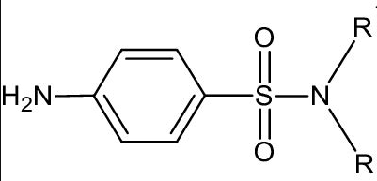

DRUG ACTION POINTS
- Enzymes: Biological catalysts
- Receptors: Biological communication
- Carrier Proteins: Carry polar molecules across the cell membrane
- Nucleic Acids: Genetic Information
- Lipids & Carbohydrates: Structural part of cell membrane

DRUG RECEPTOR INTERACTION
- Antagonists: Bind to receptors sites to block chemical messengers
- Agonists: Mimic chemical messengers

COMPETITIVE AND NON-COMPETETIVE INHIBITORS
- Competitive drugs:These drugs compete with the chemical messengers and attach themselves where chemical messengers want to attach.
- Non-Competitive drugs: These drugs do not compete with the chemical messengers of our body and attach themselves to the Allosterric sites and change the shape of the active site thus, the chemical messengers work is inhibited.

Allosterric sites: Non competetive sites where only drug can act but the enzymes cannot as it is not an active site.
TYPES OF DRUGS
- Antacids
  - Inorganic: Sodium Hydrogencarbonate & Aluminium/Magnesium hydroxide(Does not increase pH above neutrality)
  - Organic (Anti-histamines):
    - Cimetidine/Tegamet (Image below is of Cimetidine)
    - 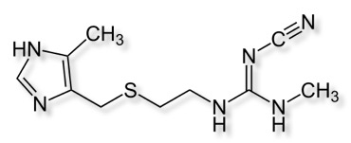
    - Ranitidein/Zantac
    - 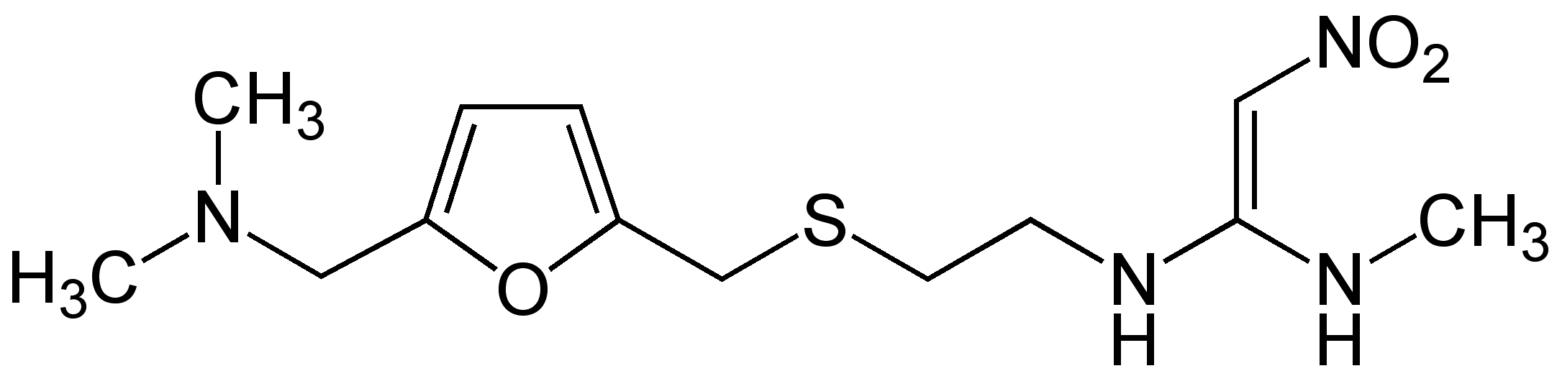
- Antihistamines
  - Antiallergic:
    - Bromopheniramine
    - 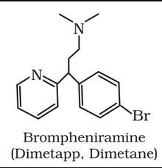
    - Terfenadine(Seldane)
    - 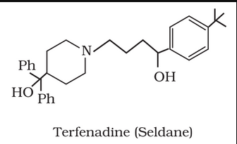

- Neurologically Active Drugs
  - Tranquilizers and Antidepressants (Used for relieving stress )
    - Iproniazid
    - 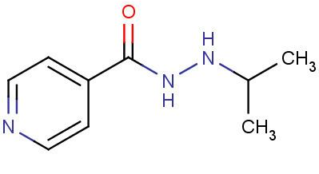
    - Phenelzine
    - 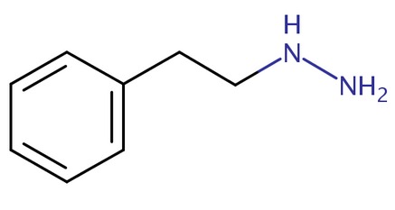
    - Mild Tranquilizers
    - 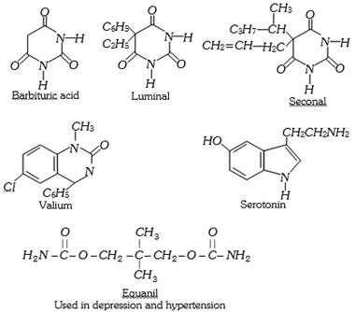

  - Anagesics
    - Non-narcotic (non-addictive)
      - Aspirin (inhibits prostagladins(inflammatory) production) and Paracetamol Useful in arthritis, fever (antipyretic) and preventing platelet coagulation (prevents heart attacks)
      - Paracetamol
    - Narcotic(addictive)
      - Morphine and derivatives (opiates) useful in postoperative pain, cardiac pain, terminal cancer, child birth
      - Heroine
      - Codeine
- Antimicrobials (Paul Ehrlich made arsenic based anti biotic for syphilis named arsphenamine/salvarsan also toxic to humans)

  - Antibiotic (Taken orally or injected)
    - Source: natural(bacteria,fungi, molds) and synthetic
    - Action Types
      - Bacteriostatic: Erythromycin,Tetracycline,Chloramphenicol
      - Bactericidal: Penicillin(Founded by Alexander Fleming it was the first antibacterial (it was narrow spectrum)) , Aminoglycosides, Ofloxacin
    - Types
      - Broad spectrum: Both gram+ and gram- bacteria
      - Narrow: either gram+ or gram- bacteria
      - Limited: single bacteria
  - Antiseptics (Can only be applied on surface of the body)
    - Furacine
    - Soframicine
    - Dettol (chloroxylenol and terpinol)
    - Bithionol(soaps)
    - Iodine(2-3% alcohol/water mixture called tincture of iodine)
    - Iodoform boric acid (eyes)
    - Phenol(0.2%)
  - Disinfectants (Used for cleaning floor, etc)
    - Phenol 1%
    - Chlorine (0.2 – 0.4 ppm)
    - SO₂ (very low conc)

- Anti-fertility
  - Estrogen (derivative ethynylestadiol/novestrol)
  - 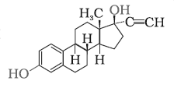
  - Progesterone (suppress ovulation, synthetic – Norethindrone)
  - 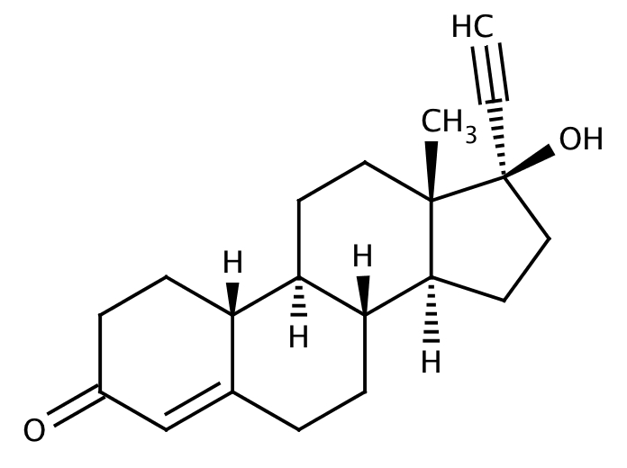

CHEMICAL MESSENGERS

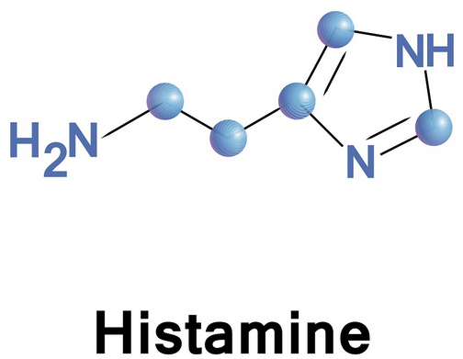
TYPES OF CHEMICAL MESSENGERS

- Neurotransmitters:
  - Histamines:
    - Stimulate secretion of pepsin and HCl
    - Vasodilators: contracts smooth muscle in the bronchi and gut and other muscles like walls in fine blood vessels
    - Nasal congestion / allergic reactions
  - Noradrenaline: ( Low concentration of it can cause depresssion)
  - Dopamine: Gives pleasurable reward and motivation
  - GABA: Calming neurotransmitter
  - Serotonin: Mood neurotransmitter
  - Acetylcholine: Learning and short term memory
  - Adenosine: Relaxes and dilates blood vessels
- Hormones:
  - Estrogen: Female sex hormone
  - Progestrone: Female hormone for carrying out body changes and function during pregnanacy

